# *Quality Learning and Superior Performance for All*

# June 21, 2017

Cobb Pediatric Therapy Services 1925 Vaughn Rd

Kennesaw, GA 30144 Attn: Mark Norris

**PURCHASING DEPARTMENT**

136 Almon C. Hill Dr. Cumming, GA 30040



Phone: 770-781-6603 Fax: 770-888-0222

# Dear Mr. Norris:

This is to advise you that your company has been awarded a contract from our **RFP# Pl7-08, Speech Language Pathology Services.** The effective date of this contract is June 21, 2017 and

# terminates on June 20, 2018. Your company is one of a pool of providers by which FCS may use for these services in accordance with the terms and conditions of Pl7-08.

This award is in accordance with all terms and conditions of the contract and with your attached pricing to remain firm for the entire contract period. This award letter is not an official order.

If you have any questions about this award, please contact Trey Tryan at 770-781-6603 or [ttryan@forsyth.k12.ga.us.](mailto:ttryan@forsyth.k12.ga.us) We appreciate your interest in the Forsyth County School System and your participation in our bidding process.

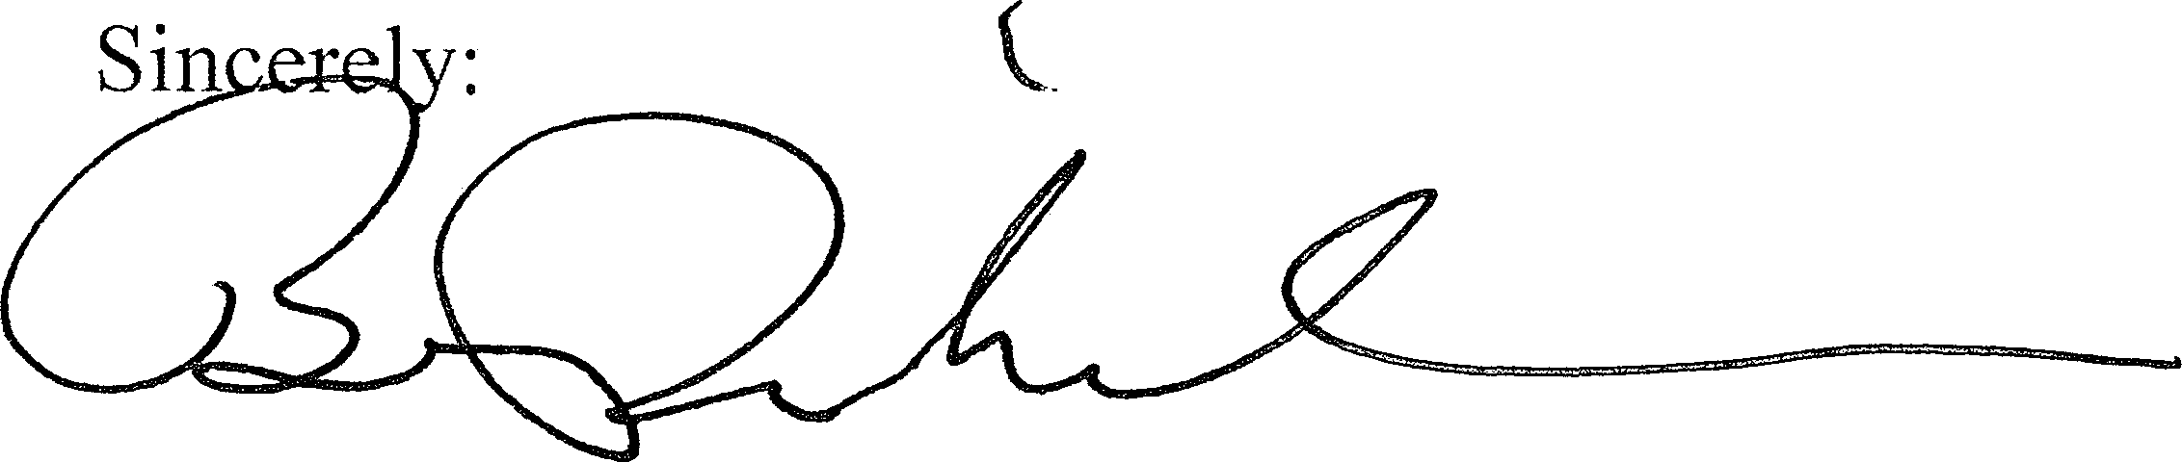

Brad Richardson Purchasing Director

cc: Sara Taylor, Director of Special Education

Paul West, Assistant Director of Special Education

June 21, 2017

Comprehensive Therapy Consultants Po Box 310686

Atlanta, GA 31131 Attn: NeShanta Wilburn

Dear Ms. Wilburn:

This is to advise you that your company has been awarded a contract from our **RFP# Pl 7-08, Speech Language Pathology Services.** The effective date of this contract is June 21, 2017 and terminates on June 20, 2018. Your company is one of a pool of providers by which FCS may use for these services in accordance with the terms and conditions of Pl 7-08.

This award is in accordance with all terms and conditions of the contract and with your attached pricing to remain firm for the entire contract period. This award letter is not an official order.

If you have any questions about this award, please contact Trey Tryan at 770-781-6603 or [ttryan@forsyth.k12.ga.us.](mailto:ttryan@forsyth.k12.ga.us) We appreciate your interest in the Forsyth County School System and your participation in our bidding process.

Sincerely:

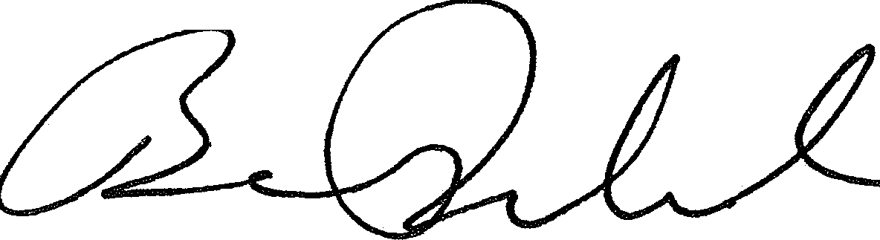

Brad Richardson Purchasing Director

disclosed and agreed upon at Award. All cost shall be label "'6.0 Cost". tabbed, and included in your RFP response.

| Item# | Description | Hourly Rate |
| --- | --- | --- |
| I. | Hourly Rate for Speech-Language Pathologist | **$57.00** |
| 2. | Hourly Rate for Speech-Language Pathologist with a PCE license in the Clinical Fellowship Process | **$54.00** |
| 3. | In the space provided below list any additional services not included in the solicitation and provide associated fee structure. |  |
|  | **Speech Language Tele-Therapy services** | $55.00/ **hr**  **with no set-up fees or minimum amounts** |

**Supplier's Name:** Comprehensive Therapy Consultants

June 21, 2017

Ardor Health Solutions 5830 Coral Ridge Dr. Coral Springs, FL 33076 Attn: Jennifer Miranda

Dear Ms. Miranda:

This is to advise you that your company has been awarded a contract from our **RFP# Pl 7-08, Speech Language Pathology Services.** The effective date of this contract is June 21, 2017 and terminates on June 20, 2018. Your company is one of a pool of providers by which FCS may use for these services in accordance with the terms and conditions of Pl 7-08.

This award is in accordance with all terms and conditions of the contract and with your attached pricing to remain firm for the entire contract period. This award letter is not an official order.

If you have any questions about this award, please contact Trey Tryan at 770-781-6603 or [ttryan@forsyth.k12.ga.us.](mailto:ttryan@forsyth.k12.ga.us) We appreciate your interest in the Forsyth County School System and your participation in our bidding process.

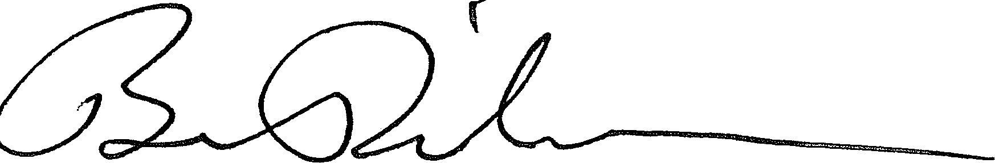Sincerely:

Brad Richardson Purchasing Director

your **RFP** response. *Tab and label with response*

| Item# | Description | Hourly Rate |
| --- | --- | --- |
| 1. | Hourly Rate for Speech-Language Pathologist | **$57** |
| 2. | Hourly Rate for Speech-Language Pathologist with a PCE license in the Clinical Fellowship Process | **$52** |
| 3. | In the space provided below list any additional services not included in the solicitation and provide associated fee structure. |  |
|  | **Occupational Therapist** | **$57** |
| **Physical Therapist** | **$57** |
| **School Psychologist** | **$57** |
| **Registered Nurse** | **$55** |
| **Teletherapy - OT** | **$55** |
| **Teletherapy - SLP** | **$55** |
| **COTA** | **$47** |
| **PTA** | **$47** |
| **SLPA** | **$47** |

**Supplier's Name: All** Source Recruiting Group, DBA - Ardor Health Solutions

June 21, 2017

The Stepping Stones Group 2586 Trailridge Dr East Lafayette, CO 80026

Attn: Laurie McCloskey

Dear Ms. McCloskey:

This is to advise you that your company has been awarded a contract from our **RFP# Pl 7-08, Speech Language Pathology Services.** The effective date of this contract is June 21, 2017 and terminates on June 20, 2018. Your company is one of a pool of providers by which FCS may use for these services in accordance with the terms and conditions of Pl 7-08.

This award is in accordance with all terms and conditions of the contract and with your attached pricing to remain firm for the entire contract period. This award letter is not an official order.

If you have any questions about this award, please contact Trey Tryan at 770-781-6603 or [ttryan@forsyth.k12.ga.us.](mailto:ttryan@forsyth.k12.ga.us) We appreciate your interest in the Forsyth County School System and your participation in our bidding process.

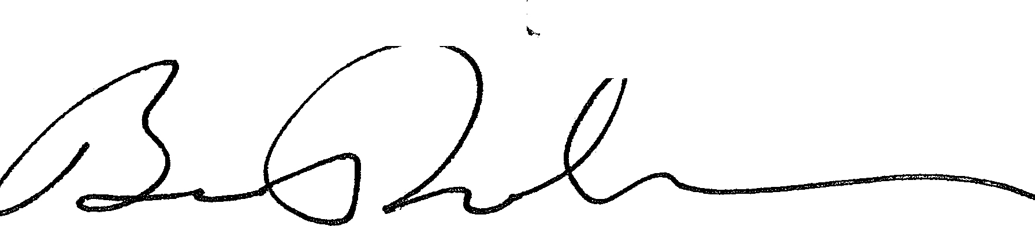

Sincerely:

Brad Richardson Purchasing Director

your RFP response.

| Item# | Description | Hourly Rate |
| --- | --- | --- |
| I. | Hourly Rate for Speech-Language Pathologist | $56.00 |
| 2. | Hourly Rate for Speech-Language Pathologist with a PCE license in the Clinical Fellowship Process | $55.00 |
| 3. | In the space provided below list any additional services not included in the solicitation and provide associated fee structure. | *NIA* |
|  |  |  |

**Supplier's Name:** The Stepping Stones Group

June 21, 2017

Progressus Therapy 1780 Kendarbren Dr.

Jamison, PA 18929 Attn: Jason Ralph

Dear Mr. Ralph:

This is to advise you that your company has been awarded a contract from our **RFP# Pl 7-08, Speech Language Pathology Services.** The effective date of this contract is June 21, 2017 and terminates on June 20, 2018. Your company is one of a pool of providers by which FCS may use for these services in accordance with the terms and conditions of Pl 7-08.

This award is in accordance with all terms and conditions of the contract and with your attached pricing to remain firm for the entire contract period. This award letter is not an official order.

If you have any questions about this award, please contact Trey Tryan at 770-781-6603 or [ttryan@forsyth.k12.ga.us.](mailto:ttryan@forsyth.k12.ga.us) We appreciate your interest in the Forsyth County School System and your participation in our bidding process.

Sincerely:

Brad Richardson Purchasing Director

**b,U CU T/HIU FORM**

**6.1** All cost considerations must be included with your response. FCS will not consider any costs not disclosed and agreed upon at Award. All cost shall be label "6.0 Cost", tabbed, and included in your RFP response. *Tab and /ahe/ fl'ith response*

| Item# | Description | Hourly Rate |
| --- | --- | --- |
| 1. | Hourly Rate for Speech-Language Pathologist | $57.22 per hour |
| 2. | Hourly Rate for Speech-Language Pathologist with a PCE license in the Clinical Fellowship Process | $56.00 per hour |
| 3. | In the space provided below list any additional services not included in the solicitation and provide associated fee structure. |  |
|  |  |  |

**Supplier's Name:** Progressus Therapy